3EJ4 Lab5

Name: Rui Qiu

Student Id: 400318681

*Part1:*

(1):

(2):

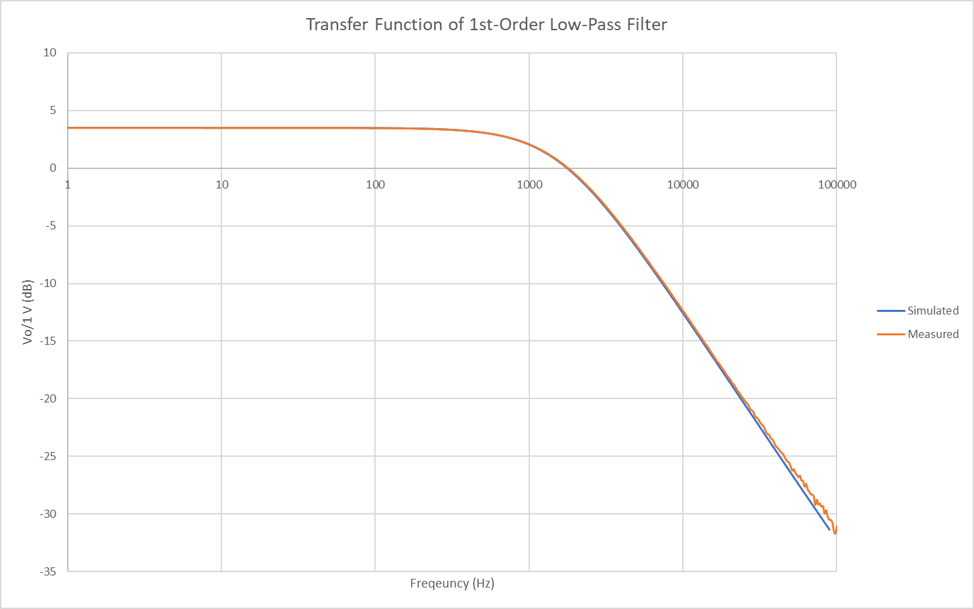

Both the simulated and the experimental transfer function graphs are very close to each other though they have different Vin input ac signal amplitudes, the simulation one has 1V and the experimental one has 100mV. The input ratio is 10:1 which is exactly the same ratio of the output Vout amplitude. Though the input value will change the output values, but based on the graph and the formula derived from (1), the gain of the active low pass filter will always be Vout/Vin which in this case, stays constant if there no components being switched.

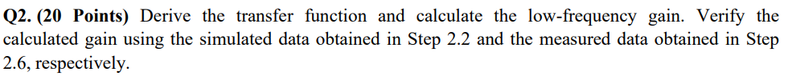

(1)

